**Practical-1**

1. **Introduction to Python Programming. Installation & Configuration of Python. Along with its all-major editors, IDLE, Pycharm, Anaconda, Jupyter, Interpreter etc.**

**Ans:**

**Step-1: Select Python version and install it in your windows.**

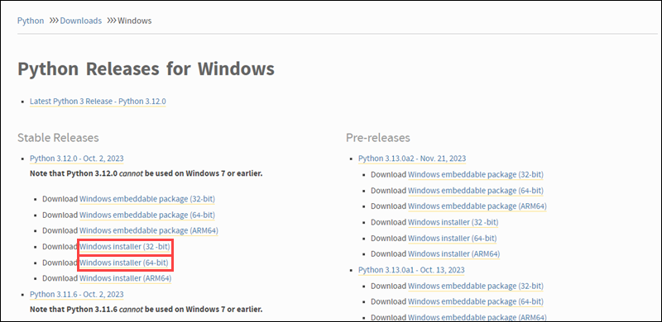

**Step-2: Run Executable Installer.**

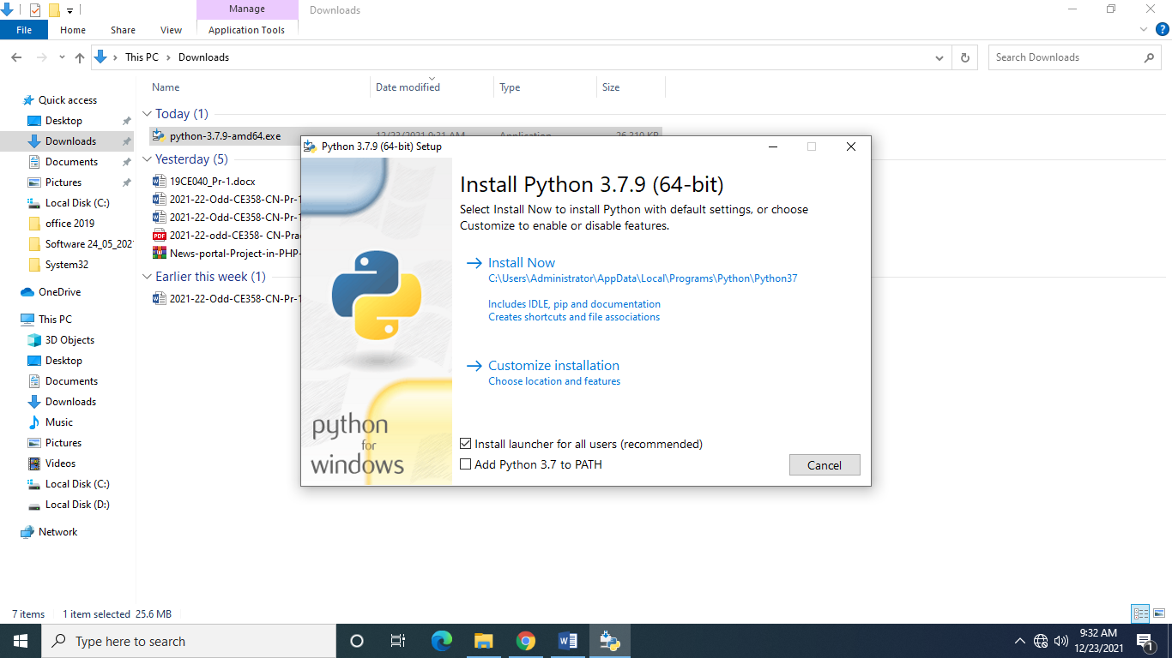

**Step-3: Choose Optional Installation Features.**

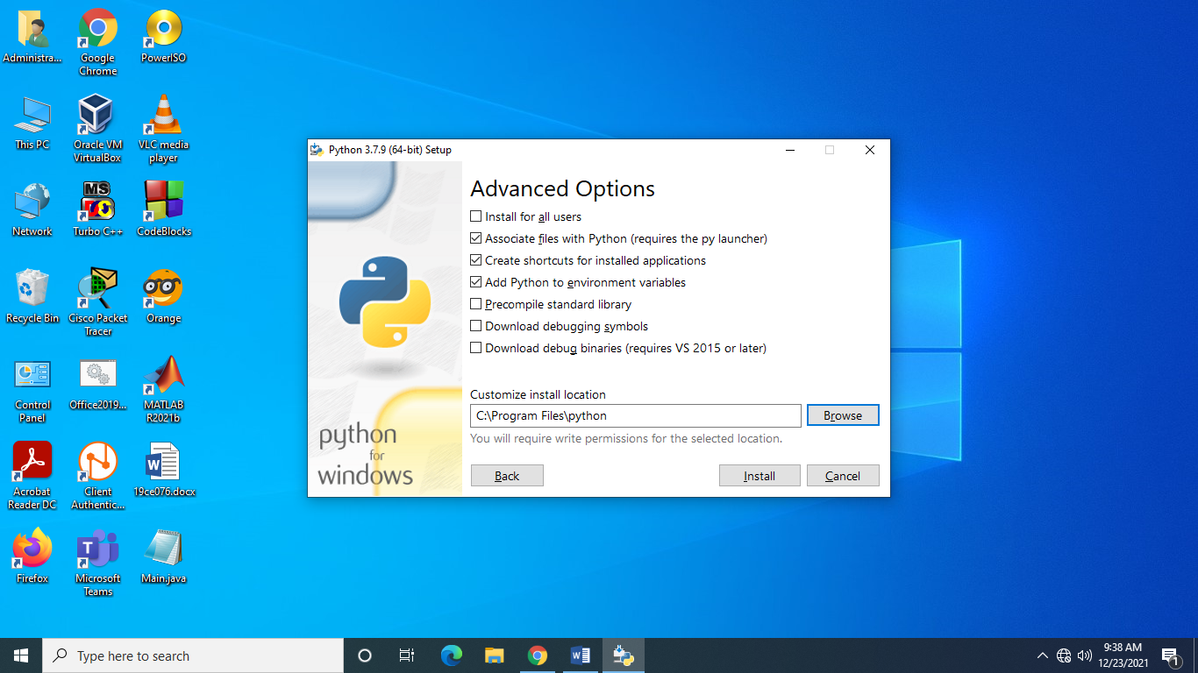

**Step-4: Verify Python was installed in your windows.**



**Step-5: Verify PIP was installed.**

pip --version 23.2.1 CMD output

**Step-6: Install Virtual Environment.**

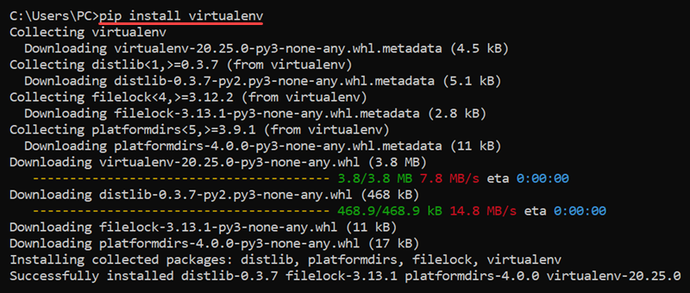

**Step-7: Python is now installedand now it is available to be used.**